Rotary Club of Kathmandu Mid-Town
Breakfast Chatter



1 December 2006 The Weekly Bulletin of Rotary Club of Kathmandu Mid-Town Bc # 22 of 2006-07

District : 3290 Web: www.rotarymidtown.org.np Club Id : 26776

DECEMBER IS ROTARY FAMILY MONTH
Who belongs to our Rotary Family?

~ Fellow club members

~ Spouses and spouse groups (e.g. Inner Wheel)

~ Children, parents and other relatives

~ Families of deceased Rotarians

~ Youth Exchange students and their families

~ Interactors, Rotaractors and RYLArians

~ GSE team members, Ambassadorial Scholars and alumni

~ Global Networking Groups

Charter Night :
On Saturday 25 November 2006 evening the Club celebrated its anniversary with a dinner meeting and lots of fun – jokes, stories, poem citations, songs, music, auction, bingo and what have you !
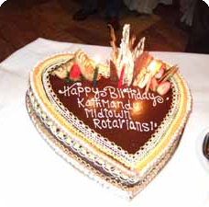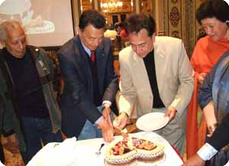
a) Birthday cake b) Charter President Dr Roop Jyoti and other charter members
joining hands in birthday cake cutting ceremony during the Charter Night celebration.

Weekly Meetings and Programs :
Date | Program/Speaker | Program/Topics of Presentation
1 Dec 2006 | Crystal Kaplan | Bhutanese refugees issues
8 Dec 2006 | Juergen Dahm | Helping poor and deprived children of Kathmandu
15 Dec 2006 | Club assembly | Club assembly
22 Dec 2006 | Dr Banu Pande

Friday, 1 December :
Ms Crystal Kaplan will be talking on the Bhutanese refugee issue. She is in the process of writing a book on Bhutanese refugees in Nepal. She will provide some background history on the issue, provide highlights on the current conditions inside the refugee camps and will share her opinion on the issue which she is going to incorporate in her book.

Charter Night Dinner :
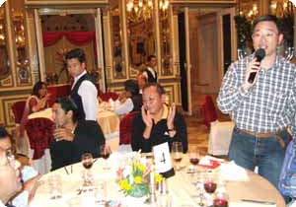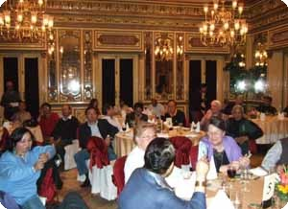
a) PP William Ma was the MC of the show. Was he singing a song, or cracking jokes ?
b) Members and guests enjoying the shows.

Goodwill Dinner :
The Club hosted a dinner on Sunday, 19th November 2006, at Tewa, Dhapakhel, Lalitpur in honour of the Rotarians and Doctors from Australia who came to Nepal to attend the inauguration of Nepal Glaucoma Eye Clinic on 18 Nov 2006 and the first Nepal Glaucoma Symposium 2006. Board members and doctors of Tilganga Eye Centre were also invited.

News on Polio :
Authorities have detected 25 new polio cases over the past week in India's most populous state, stocking fears of a resurgence of the disease that was once nearly wiped out in the country. The new report raised the number of polic cases detected in the state of Uttar Pradesh this year to 438.
A combination of factors including illiteracy and superstitious beliefs, have kept many children from receiving the immunisations. Most of the new polio cases in Uttar Pradesh have been reported from Muslim-dominated areas. In the past, banners and posters have come up in many villages asking Muslims not to allow health woekers to enter their houses. There have been propaganda that polio vaccine is actually a form of sterlisation and ploy of western world to reduce Muslim birth rate.
The government was all set to get the certification of polio eradication in 2005. However, the detection of four polio cases last year in the Terai region pushed the government's plan by another three years. Government officials had blamed four polio case in Terai to the open Nepal-India border, but the recent case in Dailekh, a hilly district in the west, has proved that indigenous Polio Virus exists.
Source : The Himalayan Times

On Lighter Side : Click at the figure ⇩

When nobody remembers anymore who was district governor way back in 2006, the impact of the work your district did during your year will still be felt - if you did it well. If there is clean water in one more village, if someone who was unemployed now has new skills and a job, if your clubs are stronger and more active than they were, if your community is a better place, that is what will be remembered.
RI President William B. Boyd

1 December 2006 The Weekly Bulletin of Rotary Club of Kathmandu Mid-Town Bc # 22 of 2006-07

Editor: RR Shrestha, Club Service Director email: rryes@wlink.com.np

